Software Requirements Specification

for

CS 441
Version 1.1
CSUSM
Spring, 2014
Table of Contents

1. Introduction 1
1.1 Purpose 1
1.2 Document Conventions 1
1.3 Intended Audience and Reading Suggestions 1
1.4 Project Scope 1
1.5 References 1
2. Overall Description 1
2.1 Product Perspective 1
2.2 Product Features 1
2.3 User Classes and Characteristics 2
2.4 Operating Environment 2
2.5 Design and Implementation Constraints 2
2.6 User Documentation 2
2.7 Assumptions and Dependencies 2
3. System Features 2
3.1 Math Drill 2
3.1.1 End-users shall be able to answer presented math facts 2
3.1.2 Stimulus/Response Sequences 2
3.1.3 Functional Requirements 2
3.2 Admin Options 3
3.2.1 An admin shall be able to designate different session parameters for each End-user 3
3.2.2 Stimulus/Response Sequences 3
3.2.3 Functional Requirements 3
3.3 User Report 3
3.3.1 Admin users shall be able to view end-user activity 3
3.3.2 Stimulus/Response Sequences 3
3.3.3 Functional Requirements 3
3.4 User Designation 3
3.4.1 Users shall be able to identify themselves to the system 3
3.4.2 Stimulus/Response Sequences 4
3.4.3 Functional Requirements 4
4. System Design 4
5. Interface Requirements 4
5.1 User Interfaces 4
5.2 Hardware Interfaces 4
5.3 Software Interfaces 4
5.4 Performance Requirements 5
5.5 Safety Requirements 5
5.6 Security Requirements 5
5.7 Software Quality Attributes 5
6. Other Requirements 5
7. Approval 6
7.1 Phase 1 6
7.2 Phase 2 6
7.3 Phase 3 6

Revision History
Name | Date | Reason For Changes | Version
RL Fletcher | 1/20/2014 | Initial Release | 1.0
Corey Paxton | 02/18/14 | Release for our project | 1.1

Introduction

Purpose
This Software Requirements Document (referred to as SRS) defines the scope of the various phases of the CS 441 Software Project for Spring, 2014. (Hereafter referred to as 'Sheriff Hodor')

Document Conventions
Requirements designated as REQ-[type]-# are to be tested

Intended Audience and Reading Suggestions
The SRS is to be used by Testers, Programmers and Analysts. Only Analysts will modify the document. The SRS is organized to give an overview of 'Sheriff Hodor', followed by specifics and then covers other related requirements. It is recommended that all readers read the entire document. Testers and Programmers should pay special attention to the System Features section. Testers will use the Functional Requirements section as a starting point for their test cases.

Project Scope
'Sheriff Hodor' will be an educational math drill game based on a stopping a train robbery. The project will be divided into three phases. For the first phase 'Sheriff Hodor' will allow end-users to answer arithmetic questions presented. 'Sheriff Hodor' will allow for an Admin who will have options unavailable to other users. During the second and third phase, 'Sheriff Hodor' will be enriched with added functionalities to create a more robust software application

References
The document, Project.pdf, defines the overall goals of the Software project and can be found at http://cc.csusm.edu.

Overall Description

Product Perspective
'Sheriff Hodor' is a new, self-contained product. It is not part of any larger system.

Product Features
'Sheriff Hodor' is a stand-alone system for drilling and learning math facts. The details of the product are provided in Section 3.

User Classes and Characteristics
The Software will be used by an Administrator (Teacher) and an End-user(Student).

Operating Environment
The Software should run on the Windows XP, Windows 7 and Windows 8 platforms.

Design and Implementation Constraints
The Software will be delivered as an executable, written in C# using Microsoft Visual Studio.

User Documentation
Teams will provide a user manual which includes screen shots and explanations of the software use. The Analyst will create the manual.

System Features
In this section, give a detailed explanation of all requirements. Requirements should be concise, complete, unambiguous, verifiable, and necessary. Include how the product should respond to anticipated error conditions or invalid inputs in the Use Case documentation

Math Drill

End-users shall be able to answer presented math facts
High Priority Item
'Sheriff Hodor' shall provide a means for the End-user to enter the answer to a math fact question.

Stimulus/Response Sequences
Once the End-user is identified, The App presents the correct problem set which was predetermined by an Admin

Functional Requirements
REQ-gameplay-1: The app shall present one problem at a time with the positive numbers in green and the negative numbers in red ontop of each other lined aligned right. During subtraction of only positive numbers the higher value must be on top.
REQ-gameplay-2: The End-user shall be able to enter their answer under the presented question.
REQ-gameplay-3: A timer for each question will appear that counts up and displays the time taken on the question. The max time per question is 99.9 seconds. This value will be used in creating the score at the end of the test.
REQ-gameplay-4: If the answer is correct an animation will play in which they shoot the train robber and move onto the next train car. If the answer is wrong they will take 'damage' and it will reduce their superficial score at the end of the test.
REQ-gameplay-5: The results of the test shall be recorded in an XML document attribute that keeps track of the problem set ID, the index of each problem, whether or not they got the problem correct and the date of the test.
REQ-gameplay-6: A superficial score representing how quickly and accurately the End-user completed the test shall be shown after they complete all of the problems in the problem set. A value from 0-1000 will be displayed with the formula specified in section 4 of this document.

Admin Options

An admin shall be able to designate different session parameters for each End-user
High Priority Item
'Sheriff Hodor' shall provide a means for the Admin to setup a problem set for each End-user.

Stimulus/Response Sequences
Once the Admin is identified, setup options for all End-users are presented in which the Admin must select from a check box list of each End-user they wish to modify.

Functional Requirements

REQ-admin-1: The Admin shall be able to designate the arithmetic operation for the problem set for each End-user (addition or subtraction).
REQ-admin-2: The Admin shall be able to designate the number of problems in a set with the default being set to 10 and the max being the max numbers of problems in the problem set.
REQ-admin-3: The Admin shall be able to designate the number range represented in tiers that designate the max number allowed in each problem set (the tiers are 10, 100, 1000, 100000, and max integer).

User Report

Admin users shall be able to view end-user activity
High Priority Item
'Sheriff Hodor' shall provide a means for the Admin to view on-screen results for each user

Stimulus/Response Sequences
Once the user is selected from a table, 'Sheriff Hodor' provides a means for an Admin user to view a history of end-user activity

Functional Requirements
REQ-userReport-1: An Admin can view a summary of each End-user selected from the list displaying the name and overall % correct for that user
REQ-userReport-2 The table in which the summary is displayed for each End-user selected from the list shall have an option in which the Admin can select an End-user to display their name and each of their tests and the % correct of that test and what problems were missed in that problem set. If an End-user is selected from the table it must update the check box list so only that user is selected

User Designation

Users shall be able to identify themselves to the system
High Priority Item
'Sheriff Hodor' shall have a login screen where an Admin or User can select themselves from a drop down list.

Stimulus/Response Sequences
Once identified and logged in, 'Sheriff Hodor' will display the correct UI based on access rights

Functional Requirements

REQ-login-1: The End-user can select his/her name from a drop down list of all possible End-users sorted alphabetically with their unique login ID # after in the format of:
[First Name] [Last Name] ([unique ID#])
REQ-login-2: 'Sheriff Hodor' will display the last “login” date for the user

Problem Set Generation

Problem Sets are predefined
High Priority Item
A predefined problem set for each tier of difficulty, addition or subtraction, and positive and negative numbers allowed must be created

Stimulus/Response Sequences
When a game is loaded generate random problems from the problem set pool as questions the End-User must answer.

Functional Requirements
REQ-problemSet-1: Problem set pool is maximum 500 questions (some problem set tiers have smaller maximum because the total combination of numbers in the problem set are less than 500)
REQ-problemSet-2: Problem set with subtraction and only positive numbers must have the larger number come first

System Design
Req-gamePlay-6 formula:
if average time per answer <= 3 seconds -> (Questions correct / total # of questions) * (3000/3)
if average time per answer > 3 seconds -> (Questions correct / total # of questions) * 3000/averageTime

Interface Requirements

User Interfaces
Admin Page
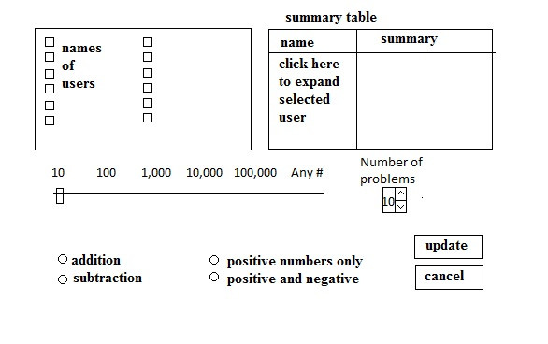

Create User
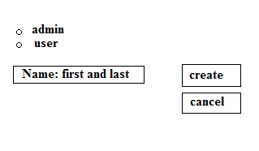

Login Screen
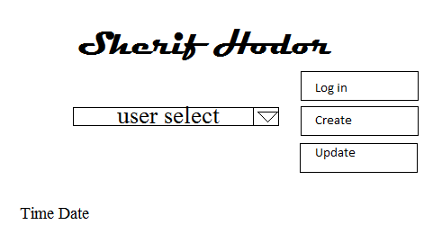

Update User

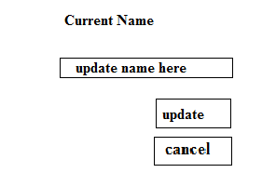

The initial user interface will consist of:
REQ-userInterface-1 A drop down list of all system users and their ID #s
REQ-userInterface-2 The correct date and time exact to the minute format tbd
REQ-userInterface-3 Login button that starts the game if an End-User is selected, or logs into the admin interface if an admin is selected
REQ-userInterface-4 Create button to create a new user or admin
REQ-userInterface-5 Update button to move you to the update user screen
REQ-userInterface-6 The title of the game displayed

The admin interface will consist of:
REQ-adminInterface-1 Check box list of all Users
REQ-adminInterface-2 Summary Table that displays all of the Users selected from the check box list. Refer to REQ-userReport-1 and REQ-userReport-2
REQ-adminInterface-3 A number slider with the tiers of 10, 100, 1000, 10000, 100000, 1000000, Any Number (which represents max int)
REQ-adminInterface-4 2 Radio buttons that alternate selectivity between addition and subtraction
REQ-adminInterface-5 2 Radio buttons that alternate selectivity between positive numbers and positive and negative numbers
REQ-adminInterface-6 A number scroll with default value of 10, minimum value of 1, maximum value of the # of problems in the selected problem set that allows you to select the number of questions presented in each test
REQ-adminInterface-7 Update button that updates all of the information for each End-User selected in the check box. Displays a pop up that tells you “Updated” with an OK selection then returns you to the login screen.
REQ-adminInterface-8 Cancel button that returns you to login screen

The update user interface will consist of:
REQ-updateInterface-1 Displays the current name and ID # of the selected user (unchanging value)
REQ-updateInterface-2 Text box for a user to update their name
REQ-updateInterface-3 Update button that displays “[Name] ([ID]) Updated” with an OK selection then returns you to the login screen
REQ-updateInterface-4 Cancel button that returns you to the login screen

Software Interfaces
REQ-software-1 The App must work as described on the following Operating Systems:
- Windows XP
- Windows 7
- Windows 8

Programmer Requirements:
The app will not interface with any other software components. No data will be shared with any other software.

The App data will be stored locally in the form of XML files. The App will directly read and write to the files.

The App requires no special communications setup or protocols.

Other Requirements
Data will be stored in a file using an XML schema to be designed by the Programmers. Programmers will “pair program”, working as a team and strive to cooperate. Programmers will take turns at the keyboard. Programmers may not talk to Testers except to hand off code for testing. All communication between Programmers and Testers will go through the Analyst(s) or bug database.

Approval
Before beginning work on The App, all parties must sign off on the SRS

Phase 1

Phase 2
ROLE | NAME | SIGNATURE | DATE
Programmer | John Fillecia
Programmer | Juliete Ly
Software Analyst | Corey Paxton | Corey Paxton | 2/18/2014
Software Analyst
Tester | Jeff Rackauckas
Tester | Mathias Lang

ROLE | NAME | SIGNATURE | DATE
Programmer
Programmer
Software Analyst
Software Analyst
Tester
Tester

Phase 3
ROLE | NAME | SIGNATURE | DATE
Programmer
Programmer
Software Analyst
Software Analyst
Tester
Tester

Appendix A: Glossary
SRS Software Requirements Specifications
Sherif Hodor The programming assignment to be completed by CS 441 student teams.
Problem Set A group of similar arithmetic problems presented in one drill session

Appendix B: Use Case Documentation
Add full documentation for each use case here
Appendix C: Issues List
< This is a dynamic list of the open requirements issues that remain to be resolved, including TBDs, pending decisions, information that is needed, conflicts awaiting resolution, and the like.>

